Revenue Schedule
Build specification — invoice-to-amortization module for the Fast Insights platform
Prepared September 3, 2026 · based on the working prototype (Revenue amortization) and the module build prompt

1. Overview
Revenue Schedule turns customer invoices into a deferred-revenue amortization schedule and shows the accrual-vs-tax timing difference. The audience is CFO-advisory clients and their bookkeepers, so the numbers have to tie out exactly and the layout should read like a working schedule, not a dashboard.
A working prototype already exists as a single-file React component; the exhibits in Section 2 are taken from it running with the demo dataset. This document specifies how to build that prototype into a production module inside the Fast Insights repo.
Before writing any code, inspect the repo and conform to what is already there:
- Framework, router, and directory conventions — put the module where existing modules live.
- Styling system (Tailwind config, design tokens, component library). Use the existing Fast Insights palette: vivid green, near-black, white, amber accent. Do not introduce a second design system.
- Data layer (ORM, migrations, API route conventions), auth, and multi-tenant scoping if present.
- Test runner, lint, and typecheck commands. New code must pass all of them.
Report what was found and what will be added before starting. If any convention is ambiguous, ask rather than guessing. Do not make large architectural changes without laying out the tradeoff first.

2. The working prototype
Seven demo invoice lines across five invoices (Jan–Jun 2026, terms of 1, 3, 12, 18, and 24 months) populate every section. Billed and Scheduled totals tie exactly at $126,300.
Exhibit 1 — Upload and invoice lines
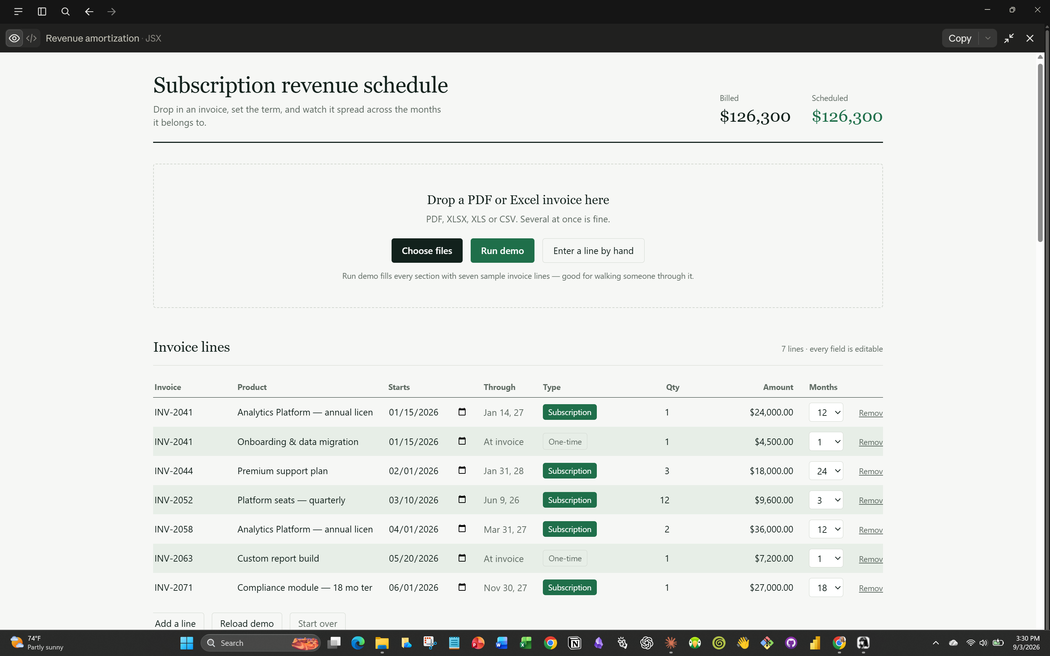
Drag-and-drop upload with a file picker and Run demo; every field in the lines table is editable inline.
Exhibit 2 — Revenue by month and revenue timeline
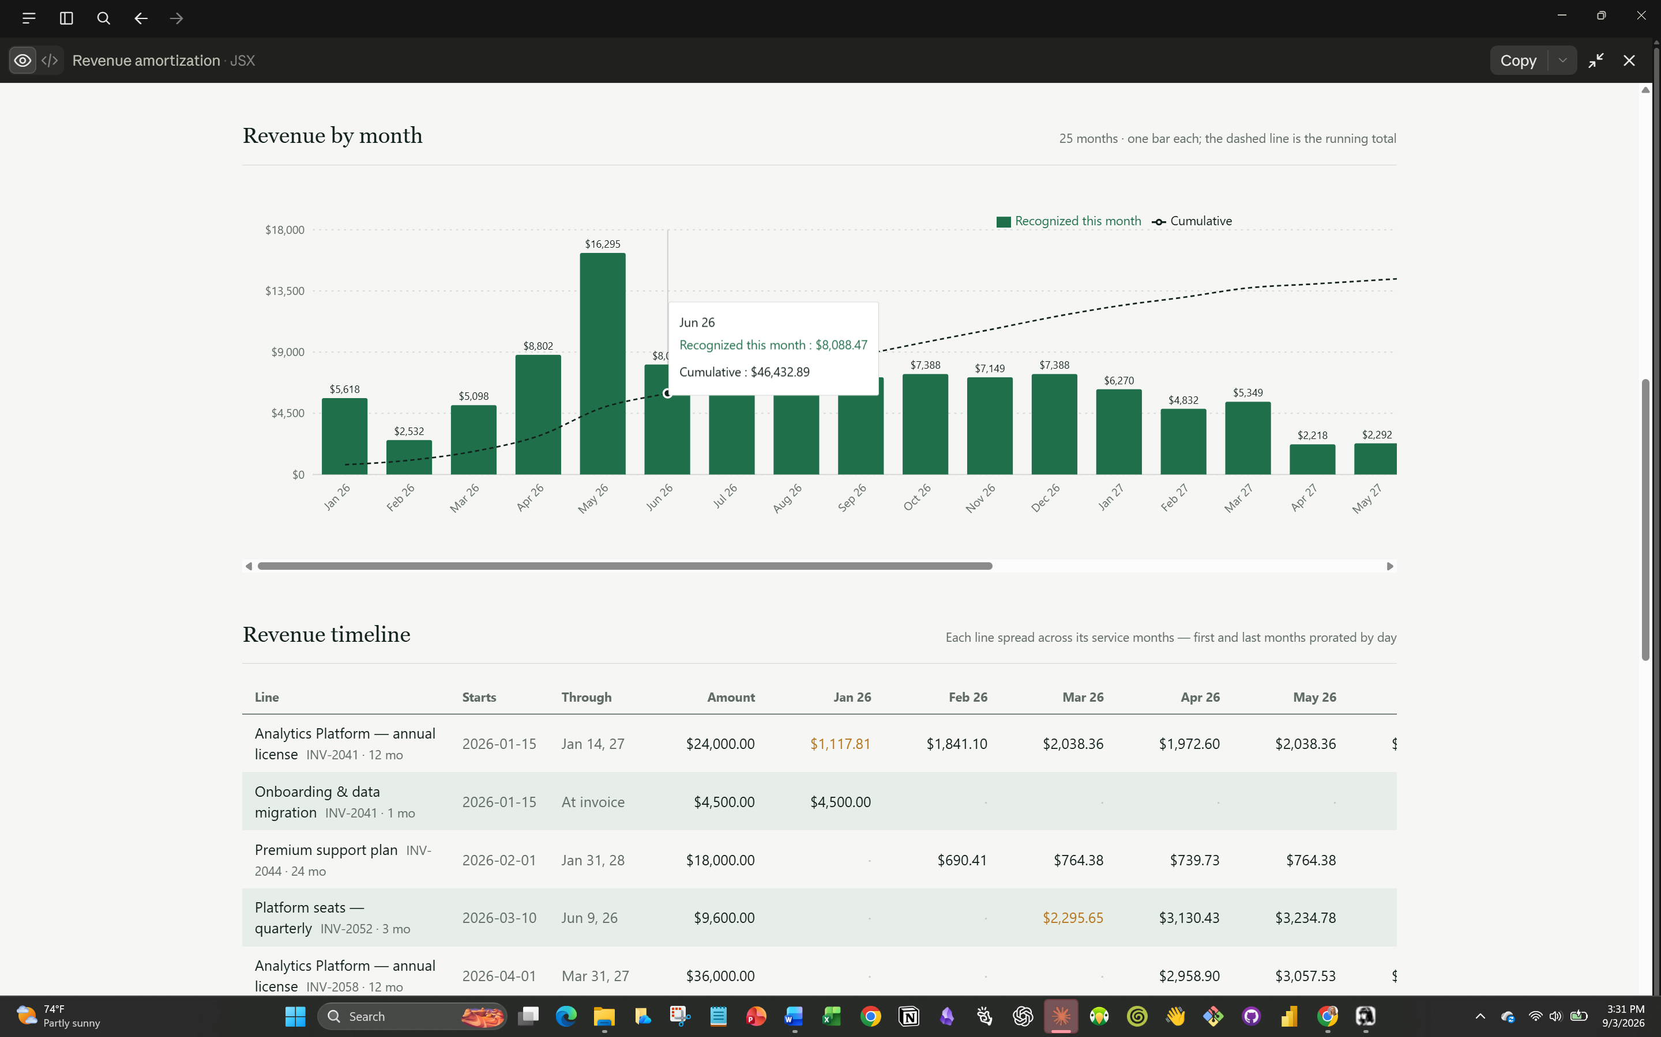
One labelled bar per month with a cumulative dashed line; the timeline matrix prorates first and last months by day (amber).
Exhibit 3 — Tax basis schedule and accrual vs. tax
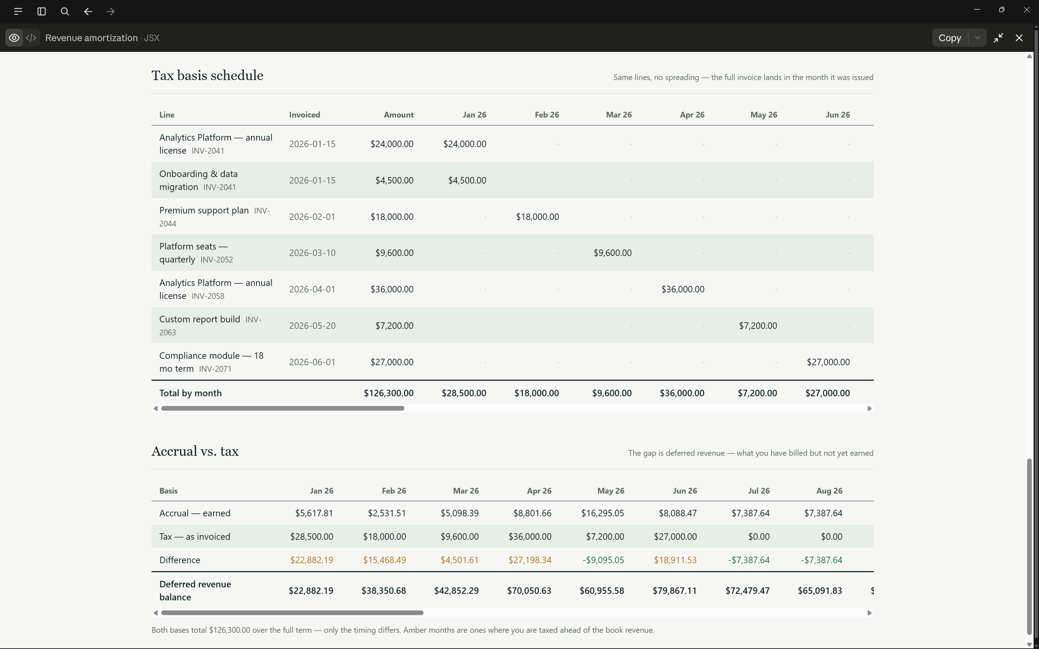
The full invoice lands in the month issued; the running gap between bases is the deferred revenue balance.

3. Functional specification

3.1 Upload and extraction
- Accept PDF, XLSX, XLS, and CSV; multiple files at once; drag-and-drop plus a file picker.
- Parse spreadsheets in-process (SheetJS or equivalent) into CSV text.
- Send PDFs to the Anthropic API as a base64 document block; send spreadsheet text as a text block. Extraction runs server-side — the API key must never reach the browser.
- Validate and clamp the model’s output before it touches state. Never trust it raw.
- On failure, show the filename and a recoverable message; the user can still enter the line by hand.
Extraction returns a JSON array of billable line items:
Field | Type | Meaning
invoiceNumber | string | Invoice identifier, repeated on every line from the same invoice
invoiceDate | string | Issue date, YYYY-MM-DD
productName | string | Product or service description
quantity | number | Units billed
amount | number | Extended line total, in dollars
isSubscription | boolean | True for recurring/term services (subscription, license, SaaS, maintenance, support plan, retainer, hosting)
termMonths | number | 1–24. Term stated on the invoice when present; else 12 for subscriptions, 1 for one-time lines
Skip subtotals, tax, shipping, and discount rows. Ship a Run demo button that loads seven sample lines across five invoices spanning Jan–Jun 2026, with 1, 3, 12, 18, and 24-month terms and two lines on one invoice. It has to populate every section — it is the sales demo.

3.2 Invoice lines table
Columns, in this order: Invoice · Product · Starts · Through · Type · Qty · Amount · Months · Remove.
- Every field editable inline. Amount displays as formatted currency ($24,000.00, tabular figures) and strips to a plain number on focus; it accepts pasted $1,250.00 and reformats on blur or Enter.
- Type is a toggle between Subscription and One-time. Flipping it resets Months to 12 or 1.
- Months is a select, 1 through 24.
- Through is derived, not editable. One-time single-month lines read “At invoice”.
- Buttons: Add a line · Reload demo · Start over.

3.3 Amortization math
This is the part that must be exactly right. Write unit tests for it first.
- Revenue starts on the invoice date, not the first of the month.
- Service period is [invoiceDate, invoiceDate + termMonths), exclusive at the end. When adding months, clamp the day to the last day of a shorter target month (Jan 31 + 1 month → Feb 28).
- Daily rate = amount ÷ total days in the period. Each calendar month gets dailyRate × days of overlap, so the first and last months are prorated by day. A 12-month invoice dated Jan 15 therefore touches 13 months.
- Round each month to cents; the final month absorbs the rounding difference so the schedule ties to the invoice total to the penny.
- Exception: a line that is One-time and 1 month is point-in-time revenue and lands whole in the invoice month rather than straddling two.
- Flag partial months so the UI can mark them.
Tests must assert: every schedule sums to the invoice total exactly; month counts are right for mid-month and month-end starts; the Jan 31 clamp behaves; the deferred balance closes to zero.

3.4 Revenue by month chart
One combined chart. Bars are the month’s recognized revenue with the dollar value printed above each bar; a dashed line on a right-hand axis is the cumulative total.
Critical: one labelled bar per month. Force every axis tick to render, angle the labels, and let the chart scroll horizontally when there are more months than fit (roughly 68px per month). Auto-thinned tick labels made several bars appear to share one month in an earlier build.

3.5 Revenue timeline
A matrix — rows are invoice lines, columns are months running left to right.
- Row: Line (product + invoice number + term) · Starts · Through · Amount · then the dollars falling in each month, with empty months shown as a dot.
- Partial months in amber, with the day count on hover.
- Footer rows: Total by month (these are the bar chart numbers) and Cumulative.
- CSV export of this exact grid.

3.6 Tax basis schedule
The same lines across the same month columns, but nothing spreads — the full invoice amount lands in the month it was issued. Footer row totals by month.

3.7 Accrual vs. tax
Four rows across the same month columns:
- Accrual — earned
- Tax — as invoiced
- Difference (amber when tax runs ahead of book, green when book runs ahead)
- Deferred revenue balance — the running gap
Both bases must total the same amount over the full term, with the deferred balance closing to zero. Assert this in a test.

4. Non-negotiables
- Money as integer cents or a decimal type in storage. No floats in the database.
- Schedules tie to invoice totals to the penny, everywhere, including the CSV.
- Uploaded invoices are client financial records: scope every query to the tenant, and decide together whether files are stored at all or discarded after extraction.
- Tabular figures on every number column so digits align down the page.
- Give currency columns real width. Formatted dollars need more room than raw numbers and will truncate at the widths that worked before.

5. Decisions already made

5.1 Persistence — session only
No database, no saved invoices, no client history. Everything lives in memory for the session and is gone on refresh. Uploaded files are discarded immediately after extraction; nothing touches disk. Say so plainly in the UI, because it is a selling point for people handing over client financials.
The product is therefore the download, not the app. The user lands, uploads, sets terms, and leaves with a working Excel file they keep using. The web app is the on-ramp.

5.2 Revenue policy — pluggable from day one
A RecognitionPolicy interface with three implementations, selectable per line and settable as a default for the whole session:
Policy | Behaviour
daily (default) | Daily rate across the exact service period; first and last months prorated by day.
midMonth | Every term starts on the 15th of the invoice month regardless of invoice date. Half a month recognized in the first month and the last.
fullFirstMonth | No proration. The invoice month counts as a whole month; the term ends after exactly termMonths calendar months.
The point-in-time exception (One-time + 1 month lands whole in the invoice month) applies under all three. Each policy needs its own unit tests, and each must still tie to the invoice total to the penny.
Constraint that shapes the design: whichever policy is active has to be expressible as an Excel formula, because the export is live. Do not implement a policy in TypeScript that cannot be reproduced in a cell. Write the Excel formula alongside the TypeScript for each policy and test that the two agree.

5.3 Period close — not building it
No locking, no closed periods, no restatement controls. Instead, a disclaimer surfaced in three places: the module footer, the first sheet of every Excel export, and the header rows of CSV and journal exports. Draft text to start from:
Revenue Schedule is a support tool. It is not accounting, tax, or legal advice, and it does not constitute an audit, review, or compilation. Figures are generated from files you supply using automated extraction that can misread documents. You are responsible for reviewing every figure before relying on it and for determining the appropriate revenue recognition policy under ASC 606 or other applicable standards. Fast Insights disclaims all warranties and accepts no liability arising from use of this output. Review with your CPA before recording anything.
Have counsel review the wording, and put the enforceable limitation of liability in the terms of service — an in-app notice supports it but does not substitute for it.

5.4 Exports — four targets

Export 1 · CSV
The timeline grid as displayed. Trivial, keep it.

Export 2 · XLSX with live formulas and a connected chart
The headline deliverable. The downloaded workbook must keep working after the user edits it — change an amount, a start date, or a term in Excel and the schedule, totals, and chart all recalculate. That means real formulas, not exported values. Structure:
- Disclaimer — the notice above, plus the policy in use and the generation date.
- Invoices — a real Excel Table (ListObject) named Invoices. Columns: Invoice, Product, Start, Term, Type, Qty, Amount, Policy. This is the only sheet the user edits.
- Schedule — one row per invoice line, month columns across. Every cell a formula referencing Invoices. EDATE clamps a month-end start the same way the TypeScript does, which is why it is the right function here. Wrap in the point-in-time IF for One-time single-month lines, and make the final overlap month a plug — Amount − SUM(prior months) — so the row ties exactly. Total and cumulative rows underneath.
- Tax basis — full amount in the invoice month via SUMIFS against Invoices.
- Comparison — accrual, tax, difference, deferred balance, all formulas off the two sheets above.
- Chart — a native Excel column chart of the monthly totals with a cumulative line on a secondary axis, its series bound to the Schedule totals range so it redraws on edit.
For the daily policy each schedule cell is, in shape:
= ROUND( Amount / (EDATE(Start,Term) - Start)
* MAX(0, MIN(EDATE(Start,Term), EOMONTH(MonthStart,0)+1)
- MAX(Start, MonthStart)), 2 )
On the library: most JS spreadsheet writers handle formulas but not charts. The reliable approach is a checked-in .xlsx template that already contains the chart bound to a named range or table, with the generator writing rows into the table so the chart follows. Verify chart survival in Excel, Numbers, and Google Sheets before calling it done — a chart that silently drops on round-trip is a failed export. If the template route proves unworkable, generating server-side with openpyxl is the fallback; flag the tradeoff before switching.

Export 3 · QuickBooks Online journal entries
One journal entry per month: debit Deferred Revenue, credit Revenue, for that month’s recognized total. Emit QBO’s journal entry import CSV layout. Account names must be user-configurable — do not hardcode a chart of accounts.

Export 4 · Xero manual journals
The same entries in Xero’s Manual Journal CSV template.
For both journal exports, let the user pick monthly summary entries or one line per invoice line, and let them set the posting date convention (last day of month by default).

5.5 Monetization — entitlements at the app shell
Revenue Schedule contains no billing logic. It reads capability flags from the existing shell and nothing else. Expose a single gate: the on-screen schedule is open, the downloads require an entitlement. Wire it as canExport(format) so the free/paid line can move later without touching this module.

6. Deliverables
- The module, wired into navigation.
- Unit tests for the amortization engine covering the cases above, for all three policies.
- Server-side extraction endpoint with validation and error handling.
- The four exports, with a round-trip test that opens the generated XLSX, changes an amount, and asserts the schedule and chart recalculate.
- A short README in the module folder covering the recognition policies in plain accounting language — daily proration, mid-month, full-first-month, the point-in-time exception, rounding treatment — so a reviewer can check the logic without reading the code.

